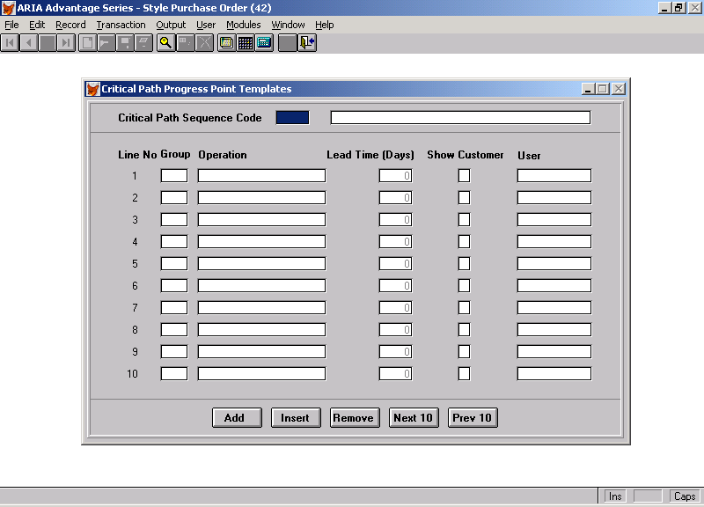

This is the Template Screen that we created that we need rewritten for Aria 2.7. We would need the standard Aria Tool Bar for Edit, Update, etc. This screen has 10 items – but if you can increase this number per screen that is OK. The heading should read as Critical Path Template Code and not Critical Path Sequence Code. This is just an example - the screen does not have to be copied exactly as long as the functionality is there. We also need to add a new field to the screen against each Operation – “Auto Recalc [ ] “.

This allows you enter an unlimited number of critical path points against one template code.

A new file called Critical Path Template File will need to be created with the following fields:

Key – being the unique template code – 6 character alphanumeric

The Line Nos are created by the system – numeric 999.

The Group will need to be vetted against a new entry in the CODES file – called “Critical Path Groups” – which will not need any related fields – just a code and description.

Operation – will be a 20 character free format field

Lead Time – is a 3 character numeric field defaulted to 0.
Show to Customer – is a one character alphabetic field defaulted to “N”.

User – must be a vetted against a valid Aria User from the SYUUSER file

Auto Recalc – is a single alphabetic field which should default to “Y” and can only be set as “Y” or “N”.

The functions at the bottom of the screen do the following:

Add – takes you to the next free line to add a new entry
Insert – allows you to insert a line below the line on which the cursor is placed.
Remove – removes the line highlighted by the cursor
Next 10 – takes you to the next screen of 10 items
Prev 10 – tales you to the previous screen of 10 items

